**How we estimated the time lags?**

We have run 5000 simulations where a Linear Regression (LR) model has been evaluated at observation points (N = 11620) with random time lags.

The random time lags have been obtained from a Uniform distribution, with a lower bound equal to the time lags provided by NSG Pilkington and the upper bound equal to,

$$Upper Bound=Lower Bound+60 hours$$

Such that,

$$random time lags∼U(Lower bound, Upper bound)$$

This allows us to get a maximum time lag of 4 days for the tags that have been assigned (by NSG Pilkington) with the maximum time lag (in this case 36 hours).

The time lag configuration that provided the lowest Mean Square Error has been chosen.

**Regression using the estimated time lags**

The following plot shows the results of the LR model using the tags at the estimated time lags and evaluated at observed points (N = 11620)

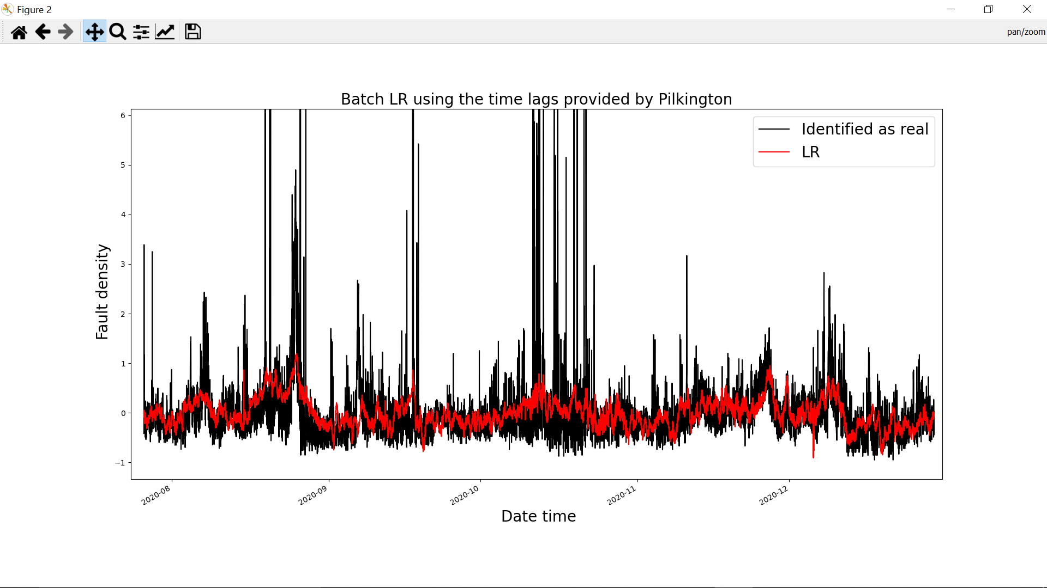

Some remarks of the regression performance with the estimated time lags,

1) The Linear Regression model now predicts only positive values of fault density.

2) The very slow trend has been captured.

3) Still struggles to follow the increases mentioned in the files UK5_FD1 and UK5_FD2